Navigation Documentation

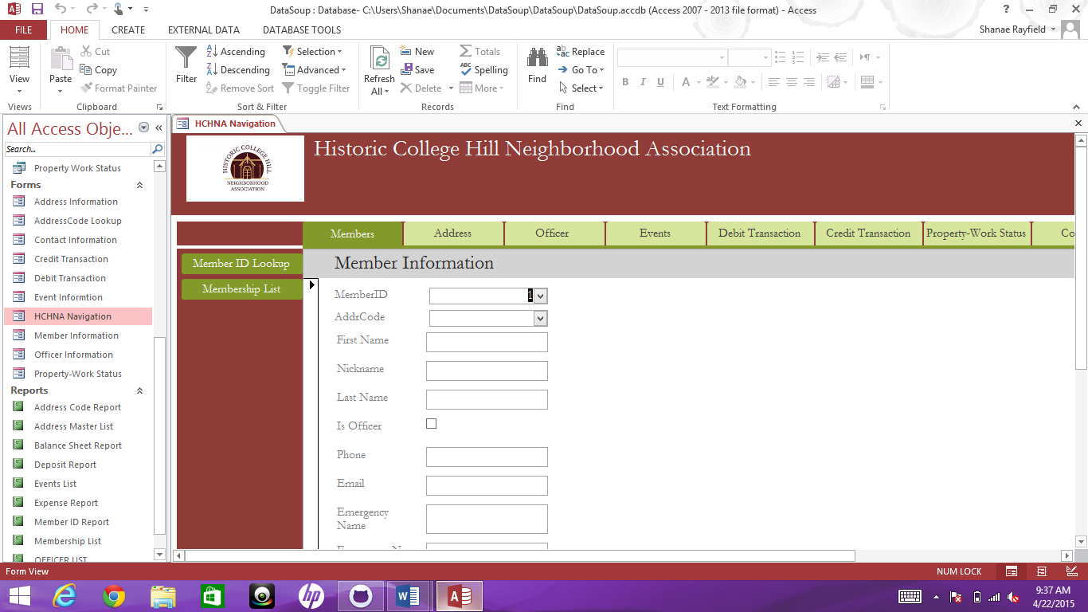

Navigation Pane Name: Member

Created By Kyle Tuczynski

This Navigation pane GUI is used to add, modify or delete a member’s record. It is used to hold contact information, emergency contact data and identify officers in the organization.

It holds the following data fields:

Member ID

Address Code

First Name

Nickname

Last Name

Is Officer

Phone

Email

Emergency Name

Emergency Number

Start Date

For questions about the data fields or their contents, please consult Section I. of this help file for a description.

The Member ID is automatically generated and should not be overridden. Address Code should be filled in if the member lives in a home within the College Hill Historical Neighborhood district. Each member should have their own record in the membership table. Spouses should not be put on the same record. Only current officers should be checked off in the ‘Is Officer’ box.

The member Id lookup and the membership list is used to reference the input fields as the user is implementing information. The reports are linked to the navigation by a tab which automatically opens when the user clicks on it. Having these reports will help to reduce user input error and increase input efficiency.

Navigation Documentation

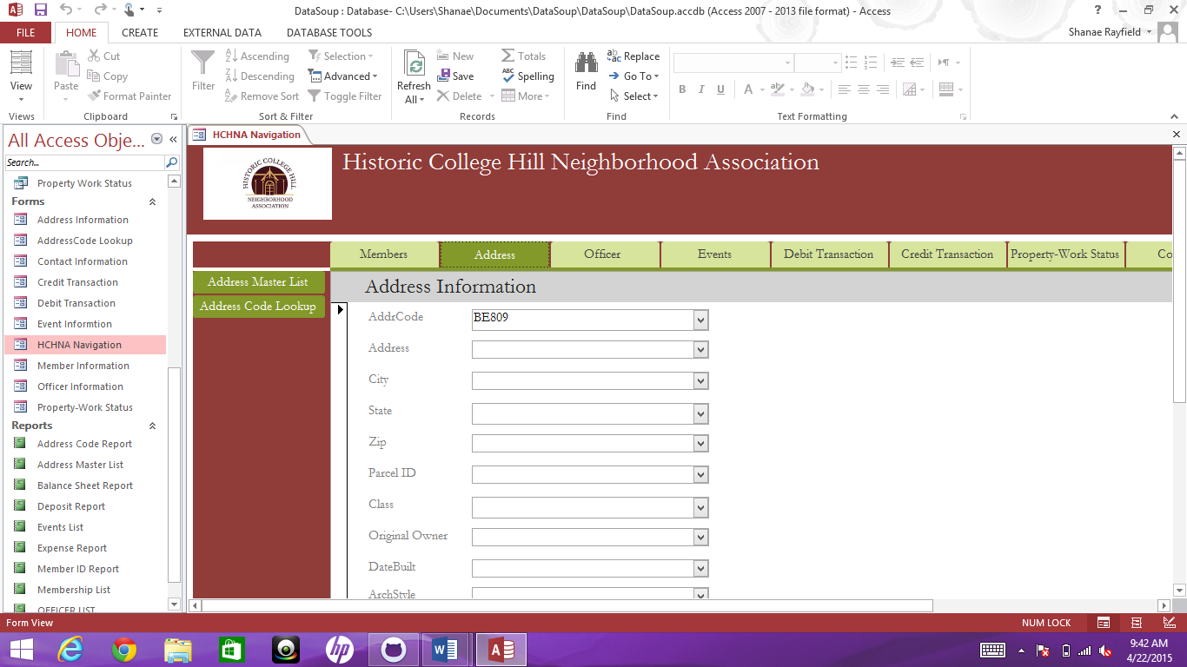

Navigation Name: Address

Created By Kyle Tuczynski

The purpose of this navigation pane is to provide a GUI input or edit historical address related data. Historical addresses should not be deleted to keep a history of each address. Address data includes the following field names:

Address Code: See Section II. Code Key for an explanation of address codes.

Address

City

State

Zip

Parcel ID

Class

Original Owner

Data Built

Architecture Type

Please see Section I for a description of field content by name.

**ADDING RECORDS:**

If you wish to enter a new address for a vendor (mason, plumber, etc.) or a supporter that is not living in a historical house within the district, please enter this information in the Contact Information form, not the Address form. Contact addresses are included in the mailing list.

**Add New Address Button**: If you which to add a new record simply press the Add New Address and input your new data. If the record refuses to add, please look to ensure you have included an Address Code because this field cannot be left empty. If Address Code is left blank, the user will get a persistent error message and must either enter an Address Code or exit the database without saving to escape the error sequence if no new record needs to be added

This form tracks the issuance of work permits and the sale of houses in the Historical College Hill district. The form contains the following fields:

Status Number: an autonumber field that should not be changed. Deleting not advised.

Address Code: See Section II for an explanation of codes used in the database.

Owner At Time

Empty

Sale Amount

Sale Date

Work Permit

Work Start Date

Work End Date

If one would like to reference information concerning address two reports are linked as clickable tabs. The two tabs are named Address Master List and Address Code Lookup. This will give the user two sources of reference material as they are working with the address entity. They will reduce input errors and increase efficiency while inputting data.

For questions about the data fields or their contents, please consult Section I. of this help file for a description.Because this form is used to track different types of actions, most of the fields are optional, but an Address Code should always be included.

Navigation Documentation

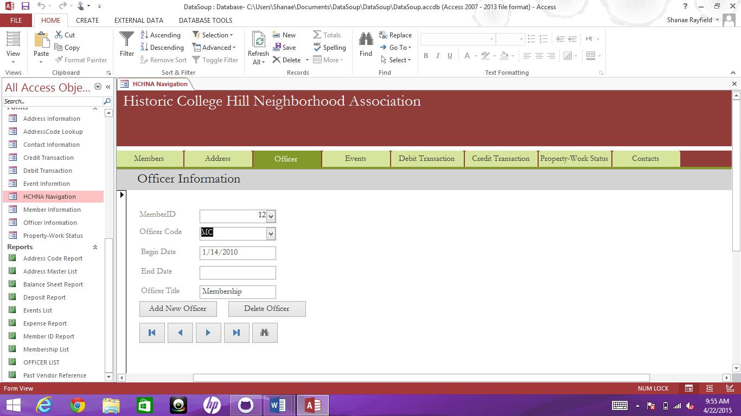

Navigation Name: Officer Information

Created By Kyle Tuczynski

The Officer Navigation pane GUI tracks current and past officers of the Historic College Hill Association. All fields of information are needed for complete historical records of association leadership. The following fields are part of Officer Information form:

Member ID

Officer Code: See Section II. Of this help file for the key of field codes.

Begin Date

End Date

Officer Title

For questions about the data fields or their contents, please consult Section I. of this help file for a description.

Member ID and Officer Code are required fields on this form. You cannot leave these fields blank. If you get caught in a persistent error code because you entered a record by mistake, it would be best to exit the database without saving.

When officers move from present to past officer status, the start year of their tenure in the post should be added to their Officer Code. Ex M2-13 for past Member-at-Large 2 who took tenure in the position in 2013. This change must be done each year because Officer Codes are required to be an original field.

Navigation Documentation

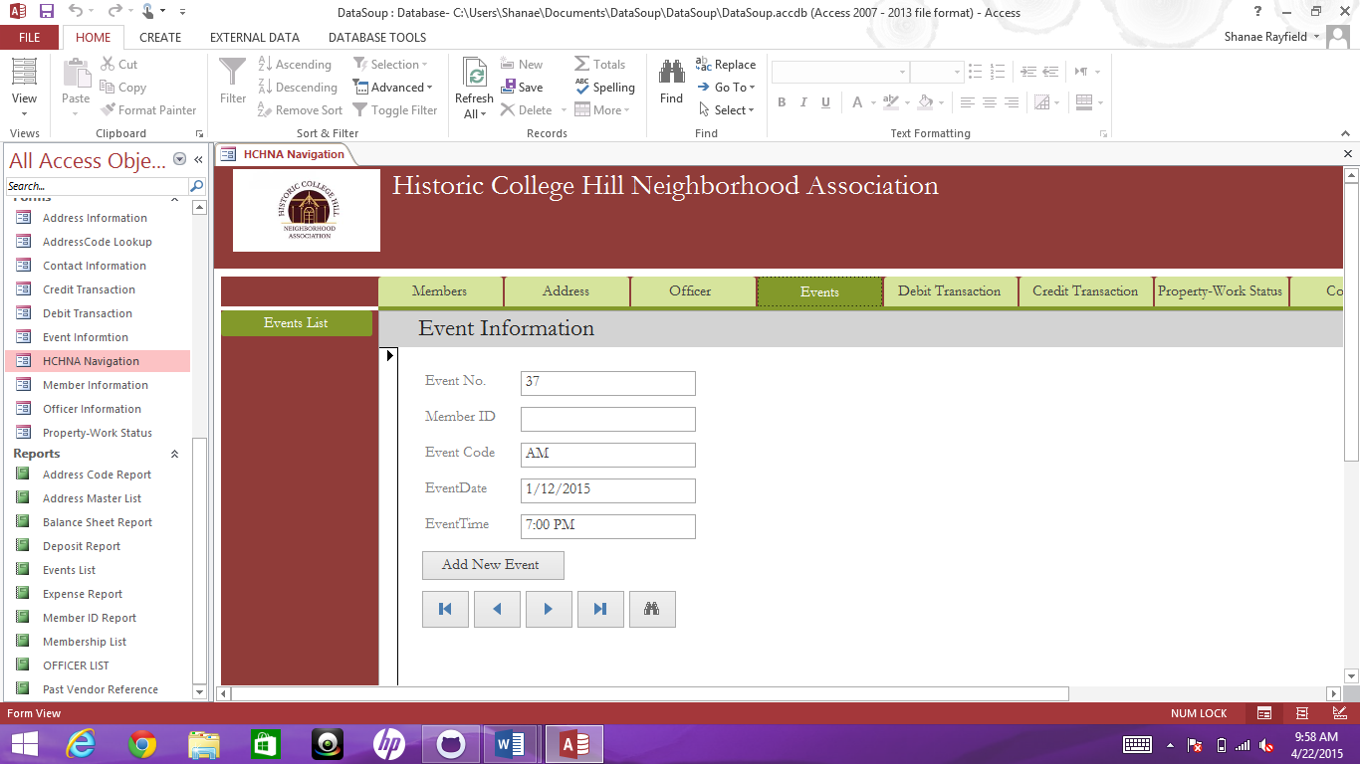

Navigation Name: Events

Created by: Kyle Tuczynski

This Navigation GUI enters new events into the Event table. The table includes the following fields:

Event Number

Member ID

Event Code: See Section II for Event Codes

Event Date

Event Time

This GUI also includes an Events List report that can be accessed by a tab located on the left vertical column. This will allow the user to see events that have been held by the HCHNA.

For questions about the data fields or their contents, please consult Section I. of this help file for a description of fields.

The form also contains a convenient add new event button, which creates a new store event. It also has easy to use seek and search buttons.

If questions arise concerning adding an event, please consult the Social Chair before entering incomplete data. The Member ID field should only be completed if someone other than the Social Chair is responsible for coordinating an event and wishes to be contacted directly.

Navigation Documentation

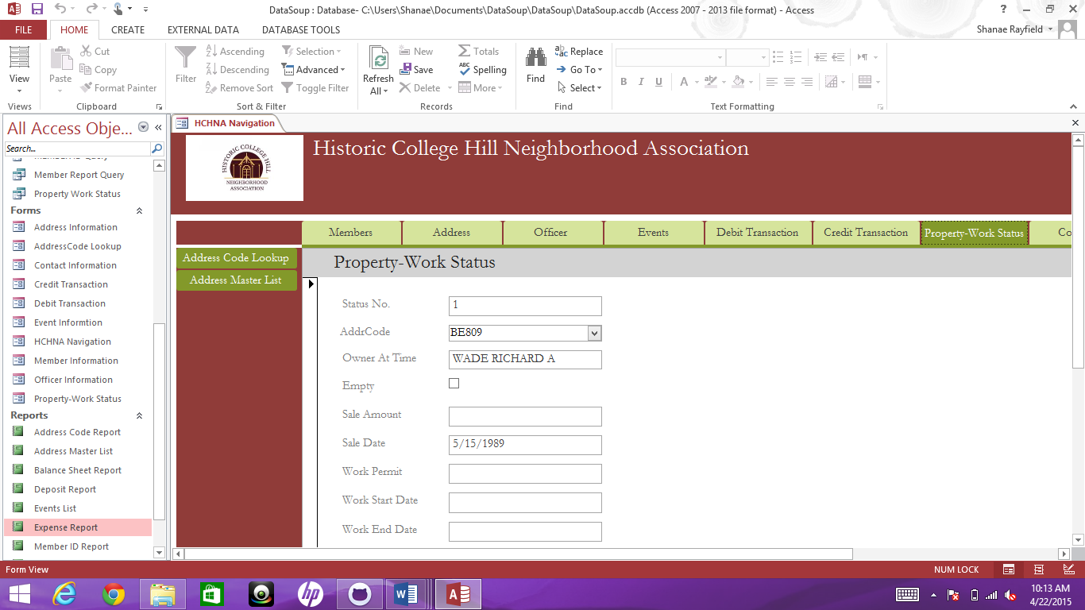

Navigation Name: Property – Work Status

Created By: Kyle Tuczynski

The Navigation GUI tracks the issuance of work permits and the sale of houses in the Historical College Hill district. The form contains the following fields:

Status Number: an autonumber field that should not be changed. Deleting not advised.

Address Code: See Section II for an explanation of codes used in the database.

Owner At Time

Empty

Sale Amount

Sale Date

Work Permit

Work Start Date

Work End Date

For questions about the data fields or their contents, please consult Section I. of this help file for a description.

The user can reference exact address information by referring to the reports Address Code Lookup and Address Master List. These reports are linked to this navigation and accessible by clicking the two tabs located on the left vertical column.

Because this form is used to track different types of actions, most of the fields are optional, but an Address Code should always be included.

Navigation Documentation:

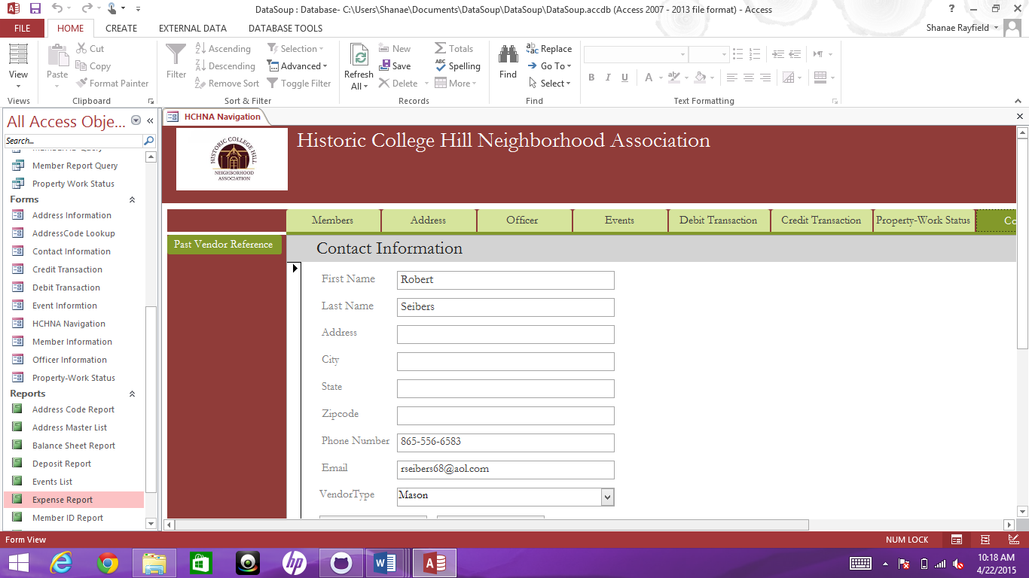

Navigation Name: Contacts

Created by: Kyle Tuczynski

The purpose of this Navigation GUI is to input or edit contact information related to a supporter of the historical organization or vendors that provide services to historical houses. The form includes the following data fields:

First Name

Last Name

Address

City

State

Zip Code

Phone Number

Email

VendorType

For more information about what should be entered in these fields, please consult Section I. of this help file.

None of the fields are required, but a name should be entered. This form can be used to store an email address, a phone number or an address, as long as it is not an address of a member within the historical district. These addresses should be inputted into the Address table using the Address Information form.

To access a reference of current and or past vendors the user can utilize the Vender Reference report. This report is located on the left vertical column. The user can click the tab at any time name Vendor Reference to pull this information.

ADDING AND DELETING CONTACT RECORDS:

Contact information can be added or deleted using the Add Record and Delete Record buttons.

NOTE: If the user accidently clicks the delete record button, a confirmation window will open verifying that the user wants to delete the current record visible in the form. If this button was clicked by accident, simply click the ‘no’ button when this happens.

Navigation Documentation

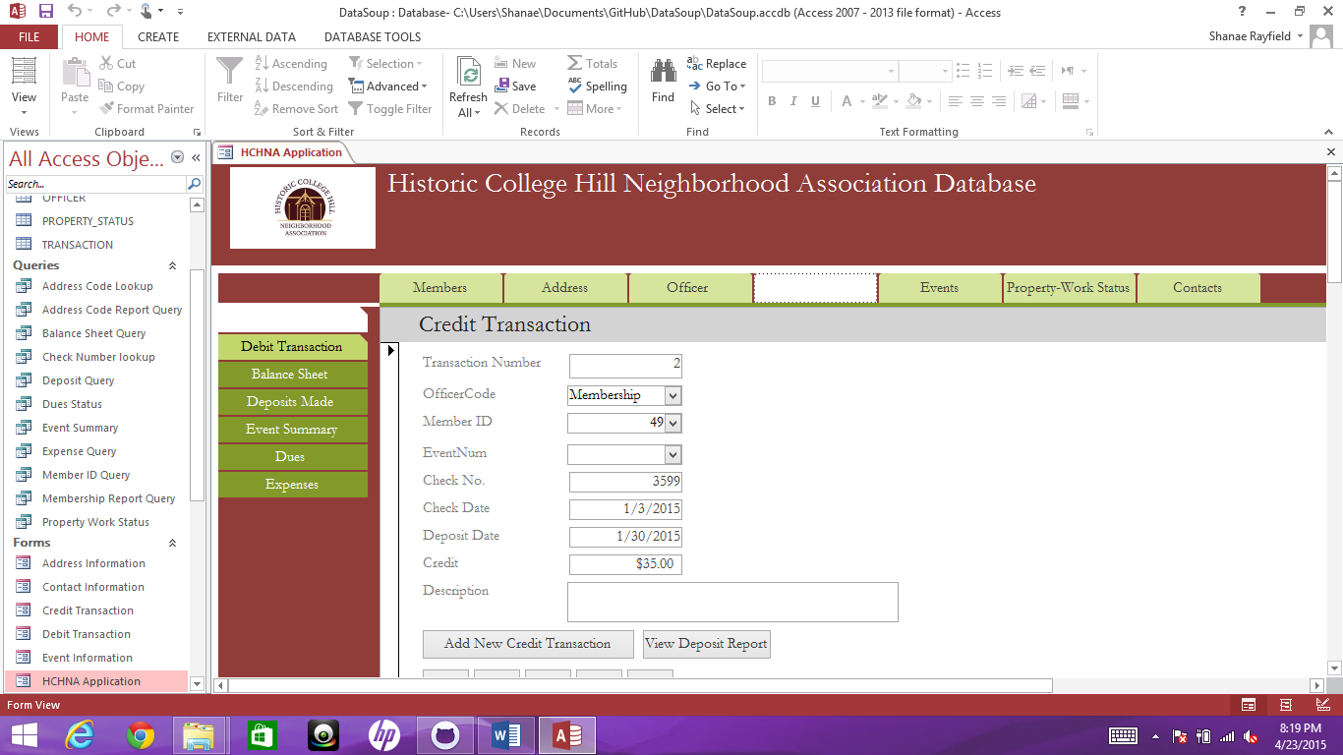

Navigation Name: Finance

Created By: Kyle Tuczynski

This Navigation GUI is for all financial operations of the Historic College Hill Neighborhood Association you can enter new credit transactions or debit transactions into the database. It can specifically deposit funds into or withdraw from the account of the association. If you are writing a check from the association to reimburse a member, then the Debit Transaction should be used.

The fields of Credit Tf f ransaction form include:

Transaction Number

Officer Code: See Section II. Code Key for an explanation of these abbreviations.

Member ID

Event Number

Check Number

Check Date

Deposit Date

Credit

Unusual Expense

Description

For questions about the data fields and the contents they are to contain, please consult

Section I. of this help file.

NOTE: An officer code must be entered with every transaction. Ex.- Member Chair (MC) for dues transactions, Social Char (SC) for event fund receipts, etc. If you do not know which officer code should be entered, please check with the treasurer before entering data into this form.

If a transaction is to be deleted, the treasurer will need to do this. If you get caught in an error message cycle for entering a transaction by mistake, it would be best to exit the database without saving to cancel the transaction.

Should you need to track deposits that you made refer to the deposits made tab located on the left vertical column of the Navigation Pane. This will enable one to review all past deposits made in report form.

Debit Transaction includes the following data fields:

Transaction Number

Officer Code: A key for Officer Code can be found in Section II of this guide.

Member ID

Event Number

Check Number

Check Date

Deposit Date

Debit

Unusual Expense

Description

For questions about the data fields or their contents, please consult Section I. of this help file for a description.

NOTE: An officer code must be entered with every transaction. Ex.- Member Chair (MC) for dues reimbursements, Social Char (SC) for event expenses, etc. If you do not know which officer code should be entered, please check with the treasurer before entering data into this form.

Should you need you need to reference any logged information concerning debit transactions the left vertical column contains to tabs. The tabs are named Balance Sheet Report and Expense Report. This will aid in reference to new and old data.

Section II of this help file has a key for Officer Codes.

If a transaction is to be deleted, the treasurer will need to do this. If you get caught in an error message cycle for entering a transaction in error, it would be best to exit the database without saving to cancel the transaction.